Thursday, June 04, 2009

Enfield magazine feed lip tuning
Just short of the chamber, you can see two tabs poking in. Those are the Enfield magazine forward feed lips, and if they are not properly adjusted, your Enfield will jam with failures to feed, and failures to strip. Sometimes on the last round, sometimes on every round, and sometimes every other round!
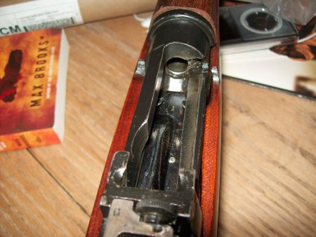
The fact that the magazine is detachable is a bit misleading. Nowadays, a detachable box magazine is so you can reload quickly. Such is NOT the case with the Enfield magazine. Each magazine must be "tuned" for each Enfield, which is why it has a serial number on it.
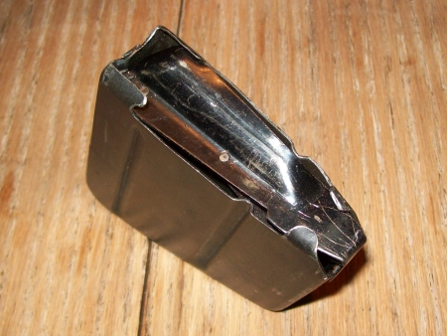
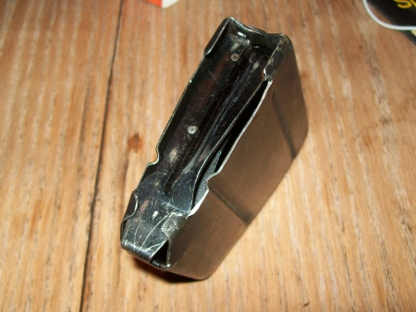
This is how an incorrectly tuned magazine looks. Note the right front feed lip, and how it is contacting the bullet.
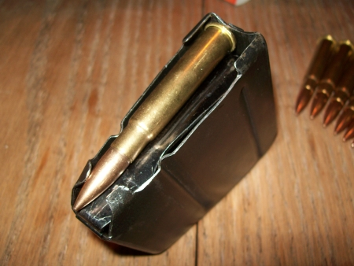
A look from the rear shows why this is a problem; the rim of the cartridge is not sitting high enough for the bolt to catch it.
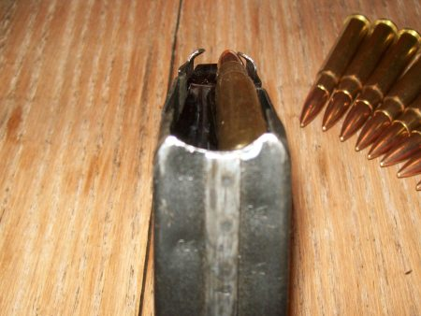
The result is this below. The bolt slides over the cartridge, and loads nothing.
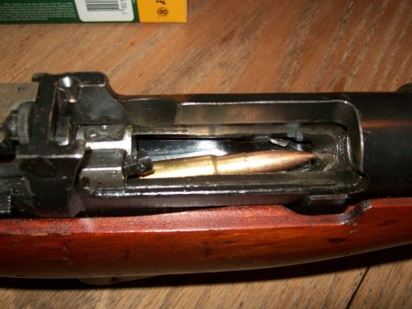
Another failure in feed lip adjustments can cause rounds to nose-dive into the feedramp, and stick.
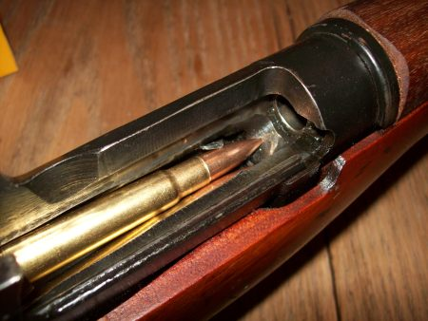
Or, rounds will skip up after escaping the front feed lip, and get caught on the top of the chamber.
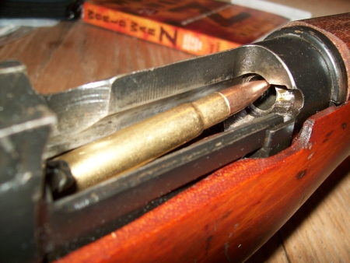
The issue here is twofold; first is the amount of bend on the feed lip, second is the amount of front/back tilt on the feed lip.
Here is a properly adjusted feed lip.
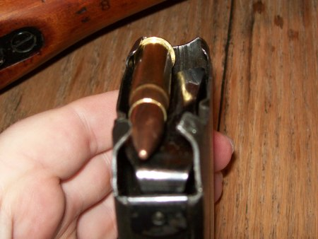
What you can see here is that the rim of the cartridge on the last round, still protrudes above the rear of the magazine, so it will catch the bolt on loading.
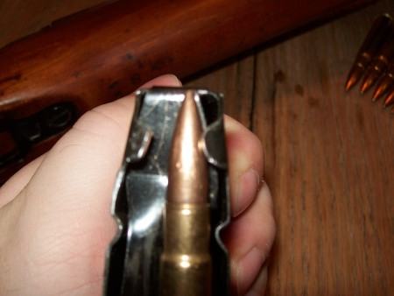
What you can't see here, is the angle of the lip that allows the bullet to slide up the feed ramp, into the chamber. You just have to test different angles with trial and error to determine the best tilt for that.
Tilt is pictured below, and will affect the ability of the bullet to slide up the feed ramp properly, and into the chamber.
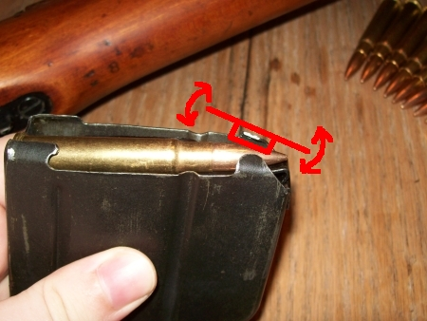
Bend is pictured below, and will affect the ability of the rear of the round to stick up above the magazine, so the bolt can catch it.
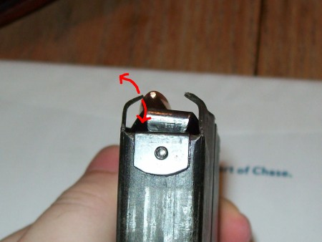
Note that the left and right side are completely separate sides, and must be set up separately!
It is possible to feed properly from the left side, and not the right side!
Make changes to each side independently, and test each side independently!
When making your adjustments, focus on one problem at a time. Adjust bend until every round sticks up high enough for the bolt to catch the rim. Once this is not a problem, adjust tilt to make sure every round feeds.
Here is an example of a properly adjusted feed lip.
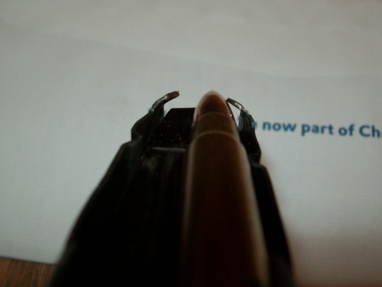
Note how strange it looks. It's barely touching the bullet, and it looks like the bullet might pop right out.
Despite the appearances, the round is secure, and feeds reliably, so if your trial-and-error method isn't getting you anywhere, try making some radical adjustments. You may be surprised what angles work.
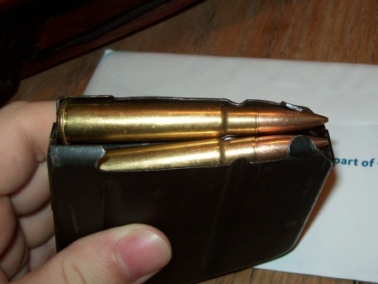
Keeping the right feed lip angle in mind, look at how different the left feed lip is in relation to the bullet.
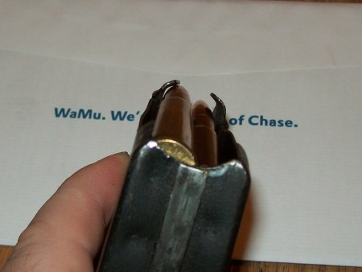
It doesn't matter how odd it looks, as long as it raises the rear of cartridge up, and feeds into the chamber without getting stuck.
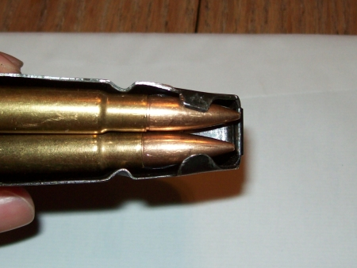
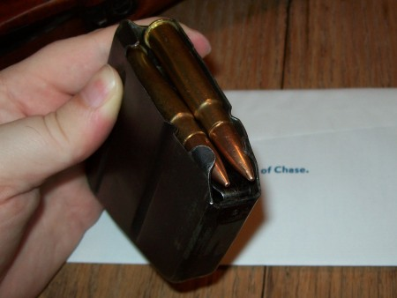
Note that since the contact between the feed lips and the bullet is so important, changing the bullet type will change the feeding.
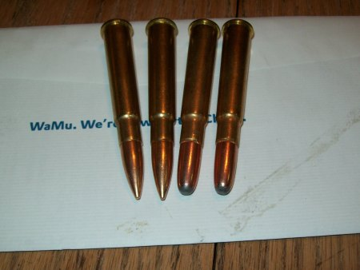
Switching the bullet type in my properly tuned magazine will result in failures.
These hunting rounds won't even stay in the magazine!
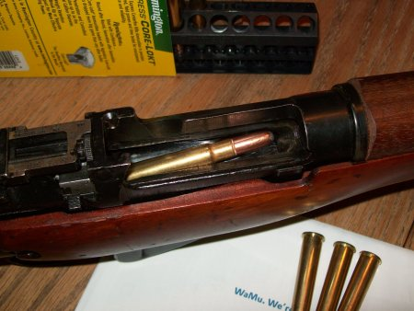
Hunting cartridges loaded in the left side nose-dive every time.
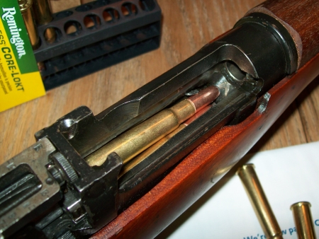
You may be better off getting two magazines for your different types of rounds, so you can swap to a magazine tuned for the hunting cartridges when you take your Enfield out to get some game.
You could also just spend the night before going through the same feed lip tuning process for the different rounds, and then tuning it back when you return from your hunting trip.
Keep your magazines tuned and happy, and your Enfield won't let you down.
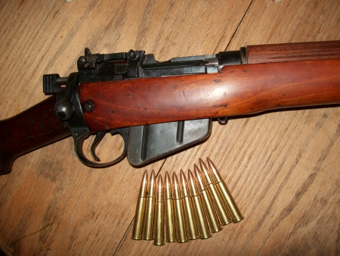
Posted by ErnestThing at 6/04/2009
Labels: diy, guns

